IDEAL COLLEGE OF ARTS AND SCIENCES,
P.G COURSES,
Vidyuth Nagar,kakinada

Department of Applied Mathematics
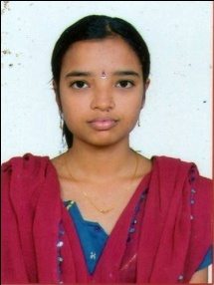

PROFILE

- Name : Teli. Nagajyothi
- Designation and Place of work : Lecturer in Applied Mathematics
Ideal College of Arts & Sciences (A)
Kakinada-533003
A.P., INDIA.
- Date of Birth : 14-08-1993
- Nationality : Indian
- Mobile no : 9553409570
- E-mail : nagajyothi.kalyani167@gmail.com
- Address for Correspondence : T. Nagajyothi
W/o S.V.V. Ramesh
D.No. 3-17B-50/18
Raja Rama Ratna Nagar
Godarigunta, Kakinada.

- Details of Educational Qualifications:
Sl. No. | Course | University | Year | Specialization
1. | M.Sc | Andhra University | 2015 | Applied Mathematics

- Experience:

Sl.No | Designation | College | Date of Joining | Experience
1. | Lecturer | Ideal college of Arts & Sciences | 01-07-2015 | 2 years 3months

- Regional/ State/National level Conferences/Workshops/Seminars

- Administrative Experience:

- Training Programs/ Courses attended:

